GitHub Copilot extension in JetBrains IntelliJ IDE

1. Copilot Account Setup through Mail Invitation
2. Installing the GitHub Copilot plugin in your JetBrains IDE
3. Suggestions

# Copilot Account Setup through Mail Invitation

1. Users will receive the following email invitation from GitHub ([noreply@github.com](mailto:noreply@github.com)).



1. Click on the Join @GlobalLogic-India-Private button or copy and paste the URL given at the bottom of the invitation in the default browser address bar.

*[Note: Please ensure that the below steps are performed in the user’s default web browser. This will simply*

*be the Copilot sign-in process]*

**

1. Once the page is loaded, create a GitHub account with GL email id. Enter the preferred username, email address(mention global logic email id), and the password. Once the form is completed, click the Create Account and Join button.



1. A new window will appear asking the user to verify the account. Follow the instructions to verify the account and Click the Join a Free plan button.

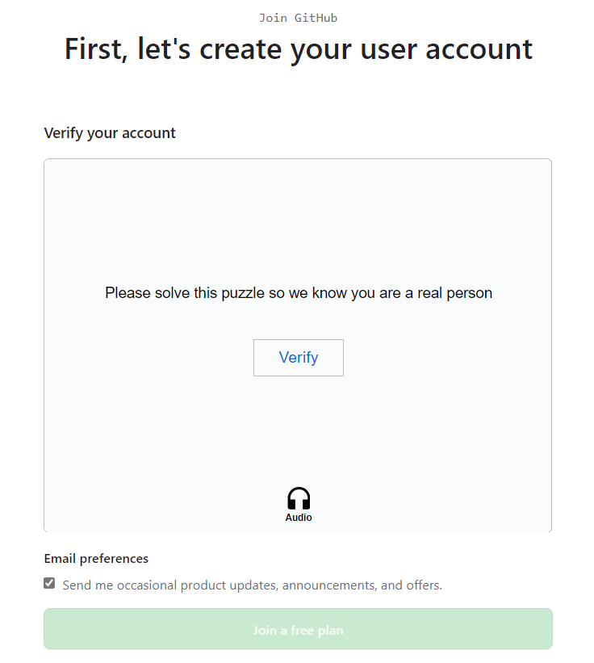

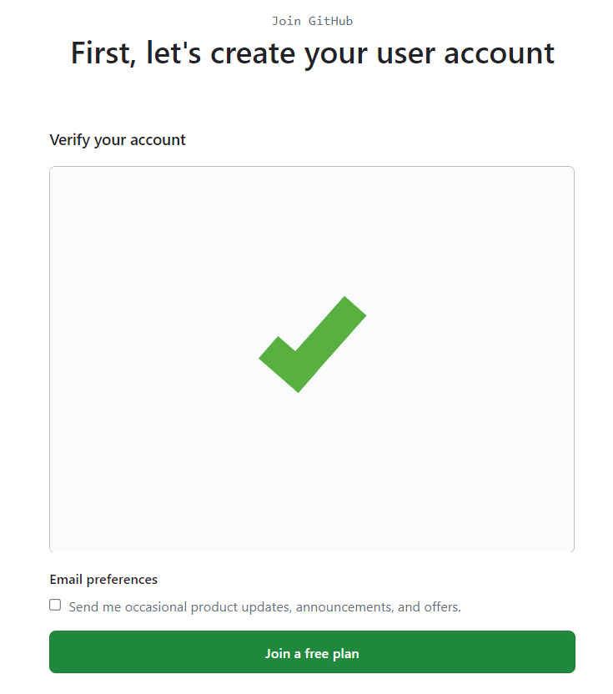

1. The below invitation page will be displayed.



1. The user will receive a GitHub launch code over email. Click on the Open GitHub button in the email.

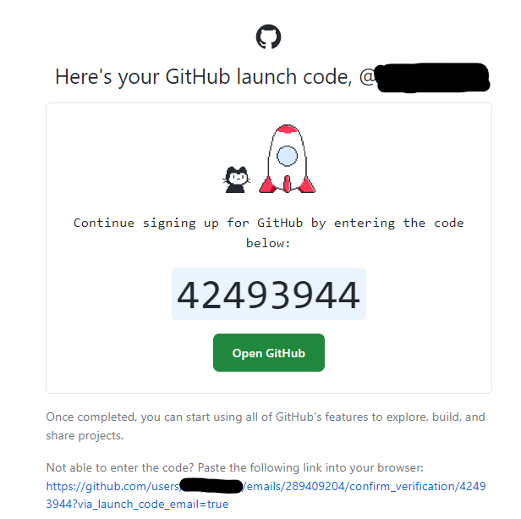

1. After clicking the Open GitHub button, the below page will be displayed. Enter the launch code.

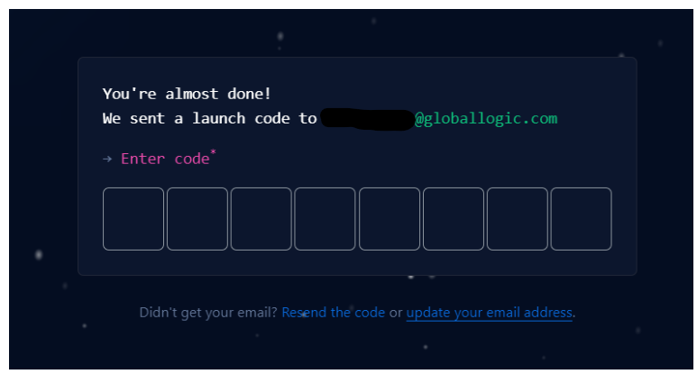

1. Once the launch code is entered and verified, users will be navigated to the GitHub account dashboard page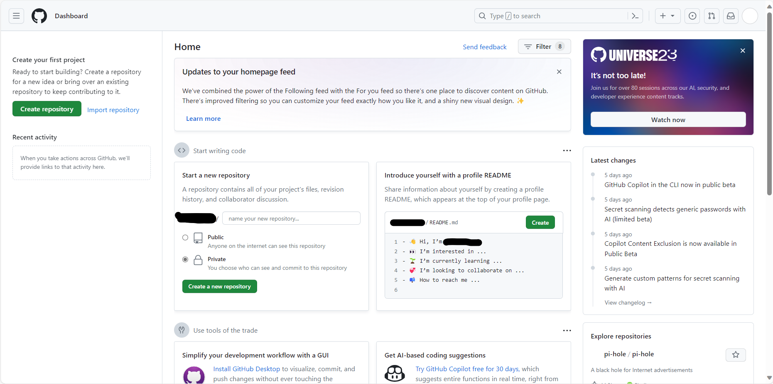
2. The user will receive another email confirming the account creation.



# Installing the GitHub Copilot plugin in your JetBrains IDE

Note : for installation of IntelliJ IDE Please refer to the Link

https://confluence.globallogic.com/pages/viewpage.action?spaceKey=ITECH&title=Standards+-+Software

1. Installing the GitHub Copilot plugin in your JetBrains IDE

Launch IntelliJ IDE > from the menu bar > navigate to the "Preferences" tab.

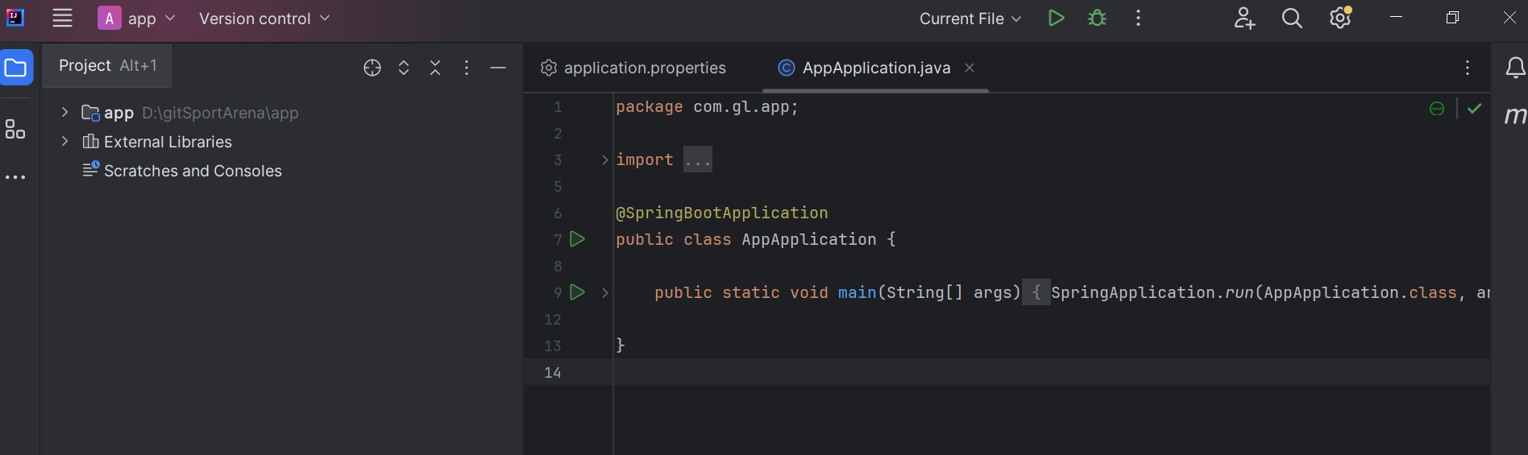

1. Click on the "Plugins" section within Preferences.

Enter the Marketplace from the Plugins section, search for "GitHub Copilot," and install the plugin.

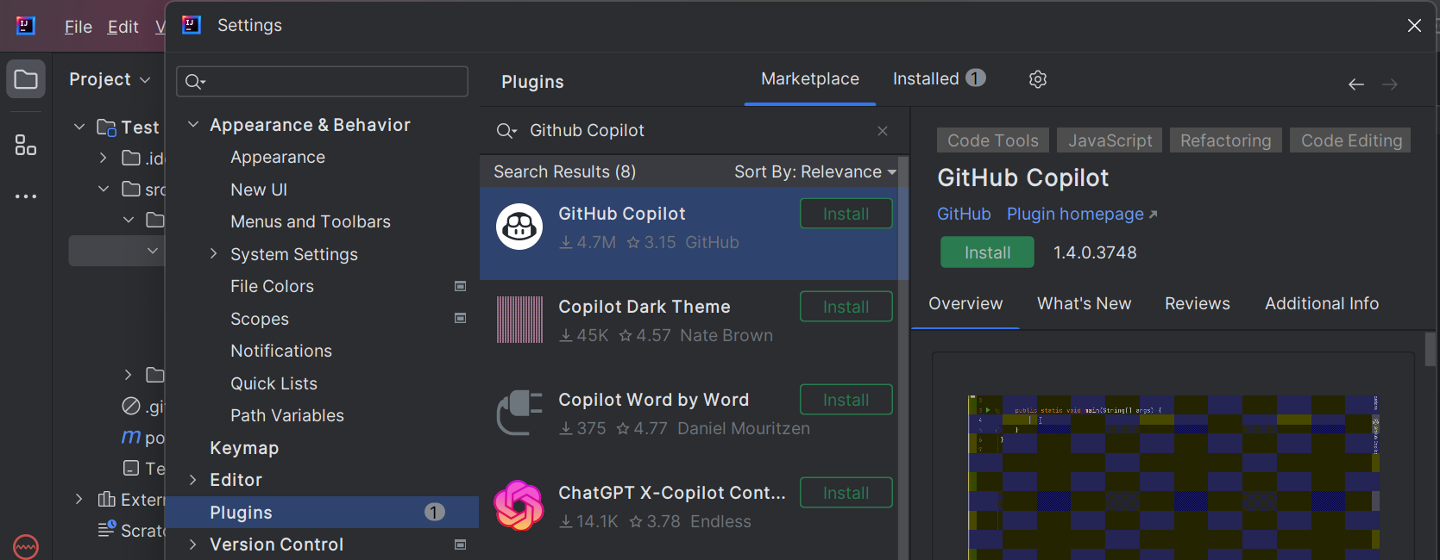

1. Once done it will ask for restart, Restart your IDE.

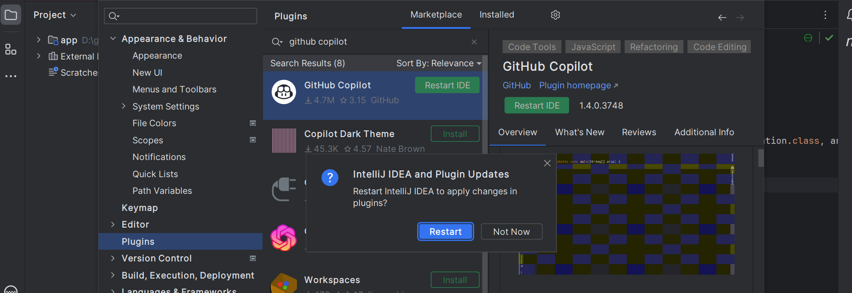

1. After installation and restart you will see pop-up for Sign in .

GitHub Copilot for IntelliJ IDEA requires a GitHub account. Sign in to your GitHub account to get started. (Chrome browser is preferred)

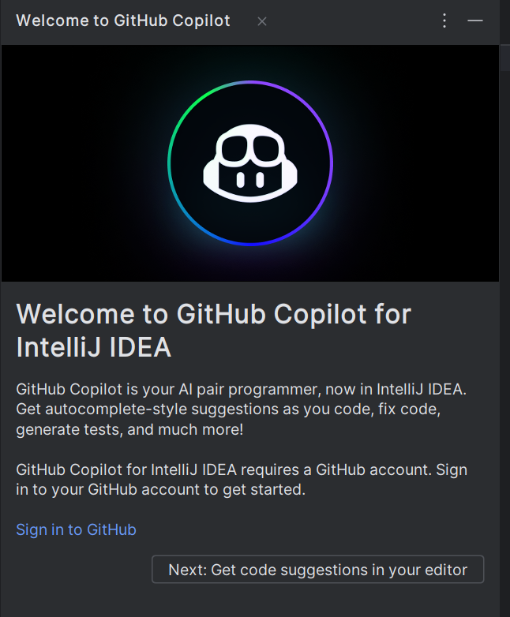

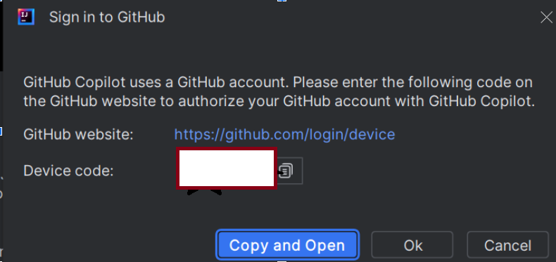

1. In the browser the activation code entry needs to be done.

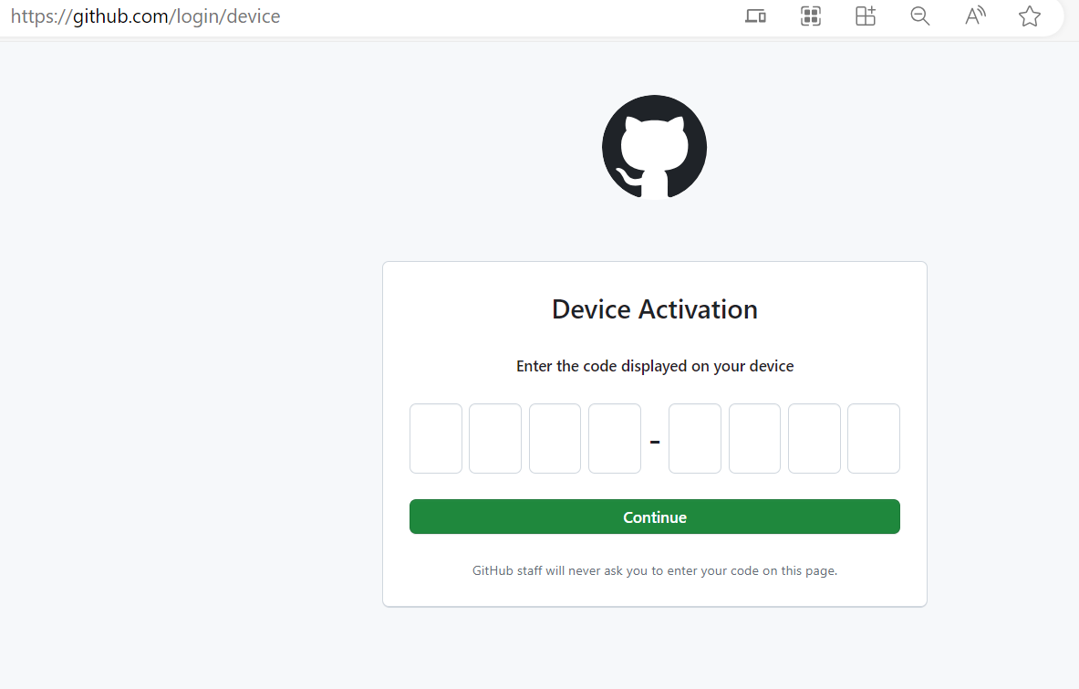

1. On allowing the Github to verify, a new tab will open in the default browser configured asking the user to authorize VS Code. Click the Authorize Github Copilot button.

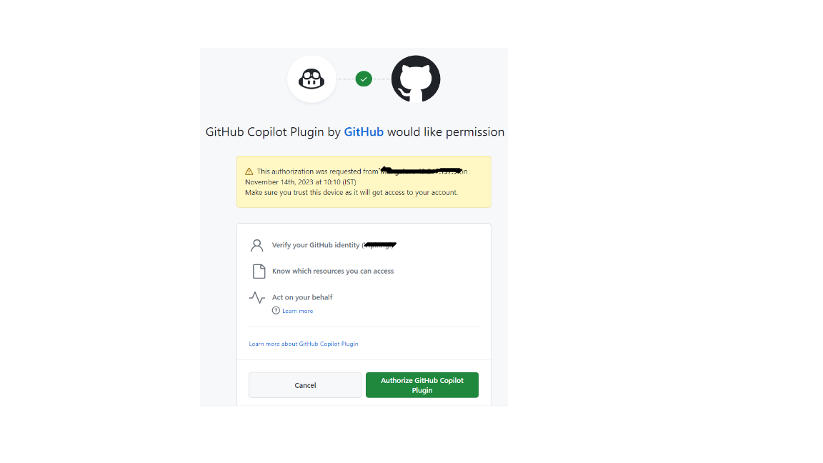

1. Click the Sign in to GitHub button at the bottom of the editor. An alert will appear asking for the user’s permission. Click the Allow button.
2. Once the Authorise Github Copilot is submitted in the InteliJ IDEA we will be able to see the icons on the right side of the editor.
   * 1. 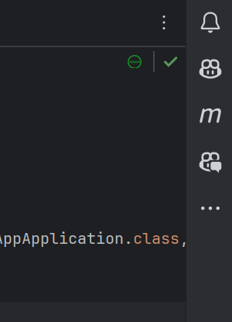

# Suggestions

1. Seeing your first suggestion

Create a new Java file in your IntelliJ IDEA project.

1. Start typing the function header in the IntelliJ IDEA editor. GitHub Copilot should provide suggestions for the function body based on the context. You can accept the suggestions by pressing “TAB” key.

public class DateCalculator {

public static int calculateDaysBetweenDates(String begin, String end) {

// GitHub Copilot will provide suggestions for the function

}  
}

body here

1. Seeing Alternative Suggestions

Alternate Suggestions Optionally, you can see alternative suggestions, if any are available.

| **OS** | **See next suggestion** | **See previous suggestion** |
| --- | --- | --- |
| macOS | Option (⌥) or Alt+] | Option (⌥) or Alt+[ |
| Windows | Alt+] | Alt+[ |
| Linux | Alt+] | Alt+[ |

Alternatively, you can hover over the suggestion to see the GitHub Copilot command palette for choosing suggestions.  
To accept a suggestion, press Tab. To reject all suggestions, press Esc.

1. Seeing multiple suggestions in a new tab

You may not want any of the initial suggestions GitHub Copilot offers. You can use a keyboard shortcut to prompt GitHub Copilot to show you multiple suggestions in a new tab.

* 1. To open a new tab with multiple additional options, press Ctrl+Enter.
  2. To accept a suggestion, above the suggestion, click Accept Solution.
  3. To reject all suggestions, close the tab.

1. Generating code suggestions from comments

You can describe something you want to do using natural language within a comment, and GitHub Copilot will suggest the code to accomplish your goal.

// Find the maximum element in an array

public int findMaxElement(int[] array) {

// GitHub Copilot will provide suggestions for the code implementation

}

// Calculate the average of a list of numbers

public double calculateAverage(List<Double> numbers) {

// GitHub Copilot will provide suggestions for the code implementation

}